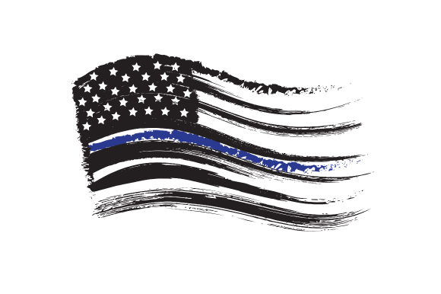

Nebraska IAI

Vendor registration form
Company Name:
Address: |  | City/State/Zip
Contact Name: | Attending: ☐ | Title/Position:
Email: |  | Phone: | Text: ☐
Contact Name: | Attending: ☐ | Title/Position:
Email: |  | Phone: | Text: ☐
Contact Name: | Attending: ☐ | Title/Position:
Email: |  | Phone: | Text: ☐

Item: | Description: |  |  |  | Cost: | Total:
Conference registration: | Includes one 8ft table; publication in NEIAI newsletters and a web link/banner on the NEIAI’s web site between April 1, 2024 and March 31, 2025.  Your company MUST provide the advertisement file. |  |  |  | $400.00 | $
 | Electricity will be needed for my display booth: |  | Yes | No
Additional Table: | One additional booth table |  |  |  | $300.00 | $
April 2, 2024
Morning Refreshments* | Includes coffee, juice, and breakfast items for all attendees |  |  |  | $1,000.00 | $
Attendee Lunches* | Estimated 150 attendees at $15/person + tax & gratuity |  |  |  | $3,000.00 | $
Afternoon Refreshments* | Includes coffee, tea, snacks/deserts for all attendees |  |  |  | $800.00 | $
Evening Social / President’s Reception* | Includes catered dinner, deserts and beverages |  |  |  | $600.00 | $
April 3, 2024
Morning Refreshments* | Includes coffee, juice, and breakfast items for all attendees |  |  |  | $1,000.00 | $
Attendee Lunches* | Estimated 150 attendees at $15/person + tax & gratuity |  |  |  | $3,000.00 | $
Afternoon Refreshments* | Includes coffee, juice, and breakfast items for all attendees |  |  |  | $800.00 | $
Additional items
Workshop Sponsor | Amount to be applied toward purchasing supplies for a workshop  Your company will be listed/advertised as a sponsor of the workshop |  |  |  | $300.00 | $
Speaker Expenses | Amount to be applied toward the speaker expenses (travel, lodging, etc.)  Your company will be listed as a sponsor of the speaker’s lecture/workshop |  |  |  | $750.00 | $
Vendor banner display | Attendance not required. Banner will be displayed throughout the conference. Company must provide banner and is responsible for shipping expenses. |  |  |  | $150.00 | $
Photo Contest Sponsor | 4 categories photo contest: Forensics/Law Enforcement, Nature/Scenery, People and Animals. Winner of each category will receive a $25 gift card. |  |  |  | $100.00 | $
Newsletter Advertisement | Includes publication in all NEIAI newsletters and a web link on the NEIAI’s web site between April 1, 2024 and March 31, 2025.  Your company MUST provide the advertisement file. |  |  |  | $300.00 | $
General Conference/ Division Support | Any funds donated to the Nebraska IAI will be used to cover the Nebraska IAI’s conference expenses; please specify the amount. Your company will be recognized as a supporter of the NEIAI Division at the annual conference.  Nebraska IAI is a non-profit 501 (C) 3 organization |  |  |  |  | $
Raffle / Door Prizes | Please list item(s) being donated:
Registration packets sponsor (Minimum qty. 200) | Name badge holder; Pens; Notepads; Lanyards; Bags (reusable bags preferred);  Water bottles; Coffee mugs; Other items (please specify):
TOTAL: $
Total x 0.035 (+3.5% is applied to credit card transactions only): $
TOTAL AMOUNT DUE: $
Payment Options
Mailing in payment |  | Please mail the check to: Nebraska IAI • PO Box 22060 • Lincoln, NE 68542
Credit card payment** |  | Email invoice to:

All event sponsors and vendors will be provided an allotment of time to address the conference attendees.
All sponsorships and donations will be recognized during the conference. Vendors are encouraged to provide their company’s banners.
Limited availability of sponsorship and vendor booths will be on a first come, first served basis.
*Food prices are estimates based on projected number of attendees, including tax and service charge.
Actual conference attendance will increase or decrease prices accordingly.
**An additional 3.5% processing fee will be added to the total amount for all credit card transactions.

THANK YOU for supporting the Nebraska IAI Division
and the local Law Enforcement Officers
Your contributions help make this conference a success!
Sincerely,
The Nebraska IAI Board of Directors

